**Five To Five Hotel** Remera, kuwa 16/05/2022

**Tin: 103291964**

**Compte: 00051-00645262-14**

**Tel: 0788676964**

Kuri Bwana Umuyobozi

w’Ishyirahamwe ry’Abanyamakuru.

Remera / Kigali

**Impamvu:** Gusaba kwishyurwa.

Bwana Muyobozi,

Tubandikiye tugirango tubasabe ko

mwatwishyura fagitire ebyiri mutubereyemo nkuko twazibagejejeho :

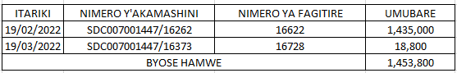

Bihwanye na miriyoni imwe n’ibihumbi magana ane na mirongo itanu na bitatu n’amafaranga

magana inani(1,453,800 frw).

Mu gihe tugitegereje igisubizo cyanyu kiza, tubaye tubashimiye uko mubyakiriye.

**HAGUMINSHUTI Jean Baptiste**

**Managing Director**